3/6/2026

Required Documents
Alex Wilcox
Alina Zimavaya
Crawford James
Luke Fixari

‘ctrlC+ctrlV’

Table of Contents
Required Documents 1
1. Project Team Name 6
2. Introduction 6
Description 6
Goals 6
3. Sponsor/Customer 7
4. Users & Audience 7
Airline Workers 7
Administrators 7
IT Support 7
Guest Users 8
5. Functional Requirements 9
6. Non-Functional Requirements 10
7. Operating Scenarios 11
8. Goal Hierarchy 12
Primary Goal 12
System Goals 12
9. High-Level System Model 13
10. High-Level Cost Estimates 14
Aircraft Leasing Costs 14
Fuel Costs (Monthly Estimate) 14
Airport Fees (Monthly Estimate) 15
Summary - Total Monthly Operating Costs 16
Revenue Projections (Monthly) 16
Profitability Analysis 17
Break-Even Analysis 17
Cost Per Flight (Average) 18
11. Glossary 19
12. Appendices 19
Appendix A – Airport Dataset (Top 30 U.S. Airports) 19
Appendix B – Performance & Turnaround Benchmarks 20
Appendix C – Security Standards & Industry References 20

Table of Contents
Table 1: Functional General Requirements 8
Table 2: Account Creation Restrictions 8
Table 3: Login Restrictions 8
Table 4: Other Login/ Account Requirements 8
Table 5: Non-Functional General Requirements 9
Table 6: Aircraft Costs 13
Table 7: Fuel Costs 13
Table 8: US Airport Fees 14
Table 9: Paris Airport Fees 14
Table 10: Total Monthly Cost 15
Table 11: Total Metro Population Calculations 15
Table 12: At 5% Market Share Calculations 15
Table 13: At 2% Market Share Profit 16
Table 14: At 5% Market Share Profit 16
Table 15: Monthly Cost Breakdown 17
Table 16: Glossary 18

Table of Figures
Figure 1: Operational Scenario 1 - Booking A Flight 10
Figure 2: Operational Scenario 2 - Creating User Account 10
Figure 3: High-Level System Model 12

Project Team Name

ctrlC+ctrlV
Alex Wilcox - Principal Developer
Alina Zimavaya - Scrum Master
Crawford James - Documentation Specialist
Luke Fixari - Configuration/Quality Assurance Manager

Introduction

Description
Panther Cloud Air is a startup airline created by a group of investors that are currently in the planning and feasibility phase of launching operations. The organization requires a prototype software system that will simulate airline operations and help determine whether their planned flight network can operate profitably.
The software will model flight schedules, aircraft operations, passenger demand, and operational costs. It will also allow airline employees to search for flights, book passengers, and analyze airline performance metrics such as revenue and passenger volume.
The system will support operations across the top thirty United States airports along with a daily route between New York and Paris. The simulation will allow administrators to run a two-week operational simulation in order to analyze performance and financial results.

Goals
Required:
- Build a flight timetable system that schedules aircraft so passengers can travel between all reachable 31 airports.
- Accurately model flight operations including taxi times, takeoff, climb, cruise, descent, landing, turnaround, refueling, crew changes, and hub constraints.
- Maintain all schedules in a database with clearly defined tables for flights, passengers, aircraft, and airports.
- Simulate two weeks of operations using the provided daily disruption scenarios (weather delays, icing, jet stream effects, cancellations, aircraft failure).
- Provide a language-specific interface, depending on location allowing passengers to search routes from any two airports.
- Generate a final operational report summarizing passengers carried, operating costs, revenue, and profit or loss.
Team Goals:
- User interface needs to be usable by someone with little to no experience.
- Ensure passengers can travel between any two airports using a maximum of one connecting flight.
- Any flight from A to B needs to load in two seconds from the database.
- Implement automated hub selection logic using a specially made algorithm that determines the best hub for profitability and passenger convenience.
- Add multiple performance metric calculators such as percentage for on-time aircraft to better understand the data.

Sponsor/Customer

The primary customer for this project is Panther Cloud Air, a group of wealthy investors who are attempting to launch a new airline.

The airline currently owns or leases the following aircraft:
- 15 Boeing 737-600 aircraft
- 15 Boeing 737-800 aircraft
- 12 Airbus A220-100 aircraft
- 13 Airbus A220-300 aircraft
- 1 Airbus A350 aircraft

These aircraft will be used within the simulation to generate schedules and estimate operational costs.

The client's goals include:
- Operating a profitable airline
- Providing high quality service at competitive prices
- Competing with larger established airlines

The prototype system will allow the client to test different flight schedules and determine whether their airline business model is financially viable.​

Users & Audience

Airline Workers
Airline workers are employees who interact with the system to assist customers and manage flight bookings.
These users must be able to:
- Search for flights between airports
- View flight schedules and availability
- Book flights for passengers
- Check passenger counts for flights
- View ticket prices and cabin information
Airline workers represent the primary operational users of the system.

Administrators
Administrators manage the system and configure airline operations.
Their responsibilities include:
- Creating flight routes within the system
- Managing and updating the flight timetable database
- Running the two-week operational simulation
- Generating reports such as passenger totals, revenue, and operating costs
- Managing user accounts and permissions
Administrators have access to all airline worker functions in addition to administrative controls.

IT Support
IT support personnel maintain the system infrastructure.
Their responsibilities include:
- Troubleshooting technical problems for airline workers
- Installing and configuring software on workstations
- Managing Docker containers and system dependencies
- Configuring the MariaDB database
- Maintaining deployment documentation
IT support staff focus on system maintenance rather than airline operations.

Guest Users
Guest users represent passengers who wish to search for flights.
Guest users are able to:
- Search for flights between two airports
- View available flight schedules
Guest users have limited access and cannot interact with booking systems or administrative functions.

Functional Requirements

ID | Requirement Description
01.01 | The software must include the following thirty airports: https://en.wikipedia.org/wiki/List_of_the_busiest_airports_in_the_United_States along with a flight from New York to Paris.
01.02 | The system must assign unique flight numbers to each scheduled flight with no duplicate flight numbers operating simultaneously.
01.03 | The system must record departure time as the time the aircraft pushes back from the gate.
01.04 | The system must record arrival time as the time the aircraft arrives at the destination gate.
01.05 | The system must display for each flight: origin airport, destination airport, departure time, arrival time, flight number, and aircraft type.
01.06 | The system must display all stopovers for multi-leg flights including stopover airports and ground time at each stop.
01.07 | The system must calculate and display total flight time from origin gate to destination gate.
01.08 | The system must calculate and display total distance travelled for each flight.
01.09 | The system must ensure flight schedules comply with airport operating hours (5:00 AM – 1:00 AM for domestic flights).
01.10 | The system must prevent scheduling flights that would arrive after the destination airport’s closing time.
01.11 | The system must allow passengers to travel from any airport to any other airport through direct or connecting flights.
01.12 | The system must display passenger capacity available on each scheduled flight.
Table 1: Functional General Requirements
ID | Requirement Description
02.001 | A user’s password must be between 8–15 characters, include one number, include one special character (!, #, $, %, &, /, ), and contain one uppercase and one lowercase letter.
02.002 | A user’s password must not contain their username, first name, or last name as part of the password.
02.003 | A user’s username or password must not contain profanity or explicit language.
02.004 | A user cannot create an account with a username that has already been used by another user.
02.005 | The user must accept the terms and conditions before creating an account.
Table 2: Account Creation Restrictions
ID | Requirement Description
02.010 | The user must be able to log in with a valid username and password to access the software.
02.011 | The user must receive an error message if an invalid username or password is entered.
02.012 | The user must be prevented from logging in if their account has been disabled by an administrator.
02.013 | The user must be locked out of their account after three failed login attempts for a period of at least six hours.
Table 3: Login Restrictions
ID | Requirement Description
02.020 | The user must be able to reset their password by providing a valid email address. A password reset email will be sent if the email is valid.
02.021 | The user must be able to log out of the software at any time once logged in.
02.022 | The user must be automatically logged out after 30 minutes of inactivity.
02.023 | The user must re-enter their password before making any account security changes.
02.024 | The user must not be allowed to reuse any of their previous five passwords when resetting their password.
02.025 | The user must receive a confirmation email after successfully changing their password.
02.026 | The user must be able to update their associated email address after verifying their current password.
Table 4: Other Login/ Account Requirements

Non-Functional Requirements
ID | Requirement Description
03.01 | The system must respond to user actions (login, flight search, viewing flight details) within two seconds.
03.02 | The system must generate and validate a complete flight schedule for all thirty airports within thirty seconds.
03.03 | The system must maintain operational availability excluding scheduled maintenance periods.
03.04 | The system must ensure that all stored flight and user data remain accurate during normal operation and unexpected failures.
03.05 | The system must log all security-critical events including logins, account lockouts, password changes, and account modifications.
03.06 | The system must ensure that all displayed times and calculated durations are consistent and accurate across different airports and time zones.
03.07 | The system must support recovery from system failures without permanent loss of user or flight schedule data.
03.08 | The system must provide a consistent user interface experience across all supported devices and platforms.
03.09 | The system must securely store all user passwords using encryption and must never store passwords in plaintext form.
Table 5: Non-Functional General Requirements

Operating Scenarios
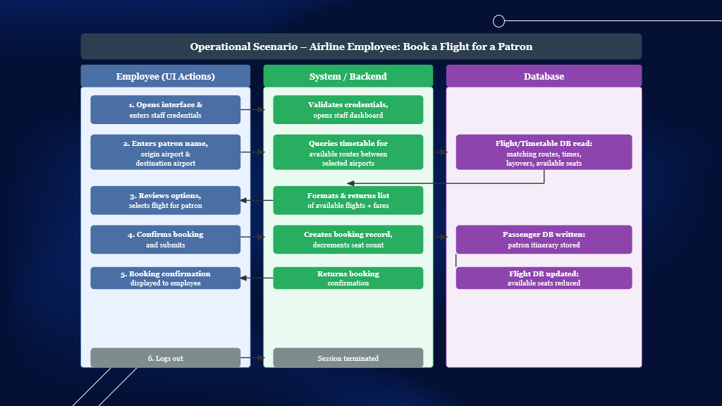
Figure 1: Operational Scenario 1 - Booking A Flight
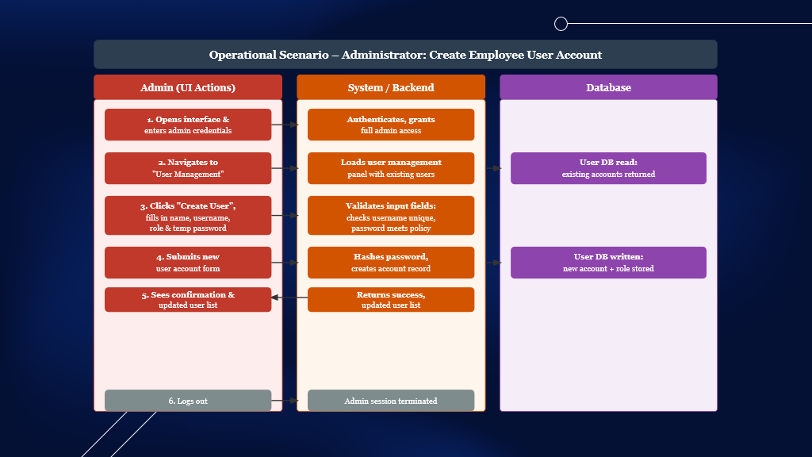
Figure 2: Operational Scenario 2 - Creating User Account

Goal Hierarchy

Primary Goal
Evaluate the feasibility of the Panther Cloud Air airline system through simulation of flight operations, scheduling, and financial performance.

System Goals
1. Flight Network Planning
- Generate valid flight schedules across the top 30 U.S. airports and the New York–Paris route
- Ensure schedules follow airport operating hours and avoid conflicts
2. Passenger Transportation
- Allow passengers to travel between any two supported airports
- Support both direct and one-layover connections
3. System Management
- Allow administrators to create and manage routes, schedules, and user accounts
- Allow airline workers to search flights and book passengers
4. Operational Simulation
- Run a two-week airline operation simulation
- Model delays, cancellations, and operational disruptions
5. Performance and Reporting
- Track passengers transported, revenue, and operating costs
- Generate reports to evaluate airline performance

High-Level System Model
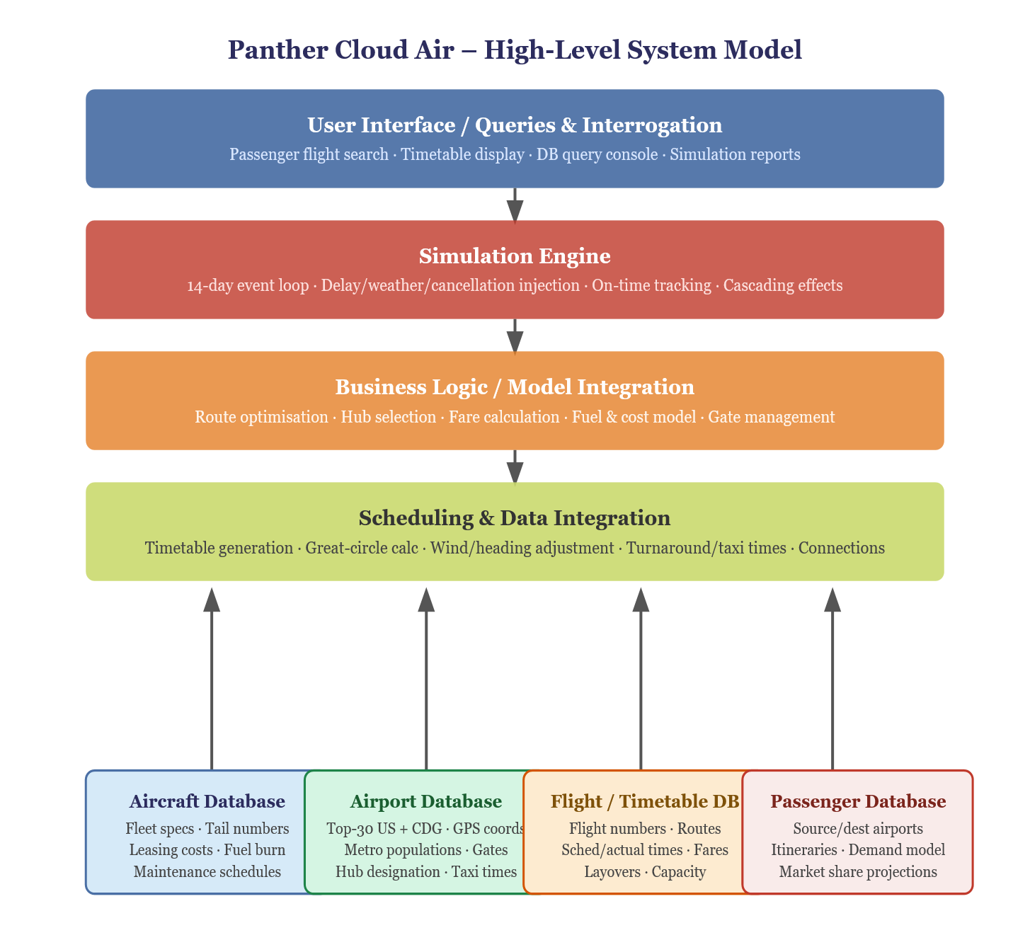
Figure 3: High-Level System Model

High-Level Cost Estimates

Aircraft Leasing Costs

Aircraft Type | Quantity | Monthly Lease per Unit | Monthly Total
Boeing 737-600 | 15 | $245,000 | $3,675,000
Boeing 737-800 | 15 | $270,000 | $4,050,000
Airbus A220-100 | 12 | $192,000 | $2,304,000
Airbus A220-300 | 13 | $228,000 | $2,964,000
Airbus A350 | 1 | $425,000* | $425,000
TOTAL LEASING |  |  | $13,418,000
Table 6: Aircraft Costs

Fuel Costs (Monthly Estimate)

Assumptions:
- Average 8 flight hours per aircraft per day
- 30 days per month
- Average fuel consumption varies by aircraft type
- US domestic fuel: $6.19/gallon
- Paris fuel: €1.97/liter (≈$2.14/liter at €1=$1.09 exchange rate)
Aircraft Type | Avg Fuel/Hr (gal) | Daily Usage | Monthly Fuel (gal) | Cost per Aircraft | Fleet Monthly Cost
Boeing 737-600 | 850 | 6,800 | 204,000 | $1,262,760 | $18,941,400
Boeing 737-800 | 950 | 7,600 | 228,000 | $1,411,320 | $21,169,800
Airbus A220-100 | 650 | 5,200 | 156,000 | $965,640 | $11,587,680
Airbus A220-300 | 710 | 5,680 | 170,400 | $1,054,776 | $13,712,088
Airbus A350 (Paris) | 1,800 | 14,400 | 432,000 | $2,674,080 | $2,674,080
TOTAL FUEL |  |  |  |  | $68,085,048
Table 7: Fuel Costs

Airport Fees (Monthly Estimate)
US Domestic Operations
Assumptions:
- Each aircraft averages 4 takeoffs/landings per day (2 round trips)
- 30 airports × 55 aircraft (excluding A350 primarily on Paris route)
- Fee: $2,000 per takeoff/landing
Category | Calculation | Monthly Total
Domestic Takeoffs/Landings | 54 aircraft × 4 ops/day × 30 days | 6,480 operations
Cost per Operation | $2,000
Domestic Airport Fees |  | $12,960,000
Table 8: US Airport Fees

International Operations (Paris)
Assumptions:
- 1 flight per day each direction (2 operations total)
- Fee: €2,100 per takeoff/landing
- Exchange rate: €1 = $1.09
Category | Calculation | Monthly Total
Paris Operations | 2 ops/day × 30 days | 60 operations
Cost per Operation (USD) | €2,100 × 1.09 = $2,289
Paris Airport Fees |  | $137,340
Table 9: Paris Airport Fees
TOTAL AIRPORT FEES: $13,097,340

Summary - Total Monthly Operating Costs

Cost Category | Monthly Amount | Annual Amount
Aircraft Leasing | $13,418,000 | $161,016,000
Fuel Costs | $68,085,048 | $817,020,576
Airport Fees (US) | $12,960,000 | $155,520,000
Airport Fees (Paris) | $137,340 | $1,648,080
TOTAL OPERATING | $94,600,388 | $1,135,204,656
Table 10: Total Monthly Cost

Revenue Projections (Monthly)

Assumptions:
- 0.5% of metro population flies daily
- Initial market share: 2%
- Target load factor: 75%
- Pricing based on 30% capacity break-even
- Average ticket price: $250 (estimated weighted average domestic/international)
Passenger Volume Calculations
Total Metro Population (Top 30 US airports): ~175,000,000
Metric | Calculation | Result
Daily flyers (0.5%) | 175M × 0.005 | 875,000
Panther Cloud Air share (2%) | 875,000 × 0.02 | 17,500/day
Monthly passengers | 17,500 × 30 | 525,000
Monthly Revenue (@ $250 avg) | 525,000 × $250 | $131,250,000
Table 11: Total Metro Population Calculations

At 5% Market Share (Year-End Goal)

Metric | Calculation | Result
Panther Cloud Air share (5%) | 875,000 × 0.05 | 43,750/day
Monthly passengers | 43,750 × 30 | 1,312,500
Monthly Revenue (@ $250 avg) | 1,312,500 × $250 | $328,125,000
Table 12: At 5% Market Share Calculations

Profitability Analysis

At 2% Market Share (Initial)
Category | Amount
Monthly Revenue | $131,250,000
Monthly Operating Costs | $94,600,388
Monthly Net Income | $36,649,612
Monthly Profit Margin | 27.9%
Annual Net Income | $439,795,344
Table 13: At 2% Market Share Profit

At 5% Market Share (Year-End)
Category | Amount
Monthly Revenue | $328,125,000
Monthly Operating Costs | $94,600,388
Monthly Net Income | $233,524,612
Monthly Profit Margin | 71.2%
Annual Net Income | $2,802,295,344
Table 14: At 5% Market Share Profit

Break-Even Analysis
Monthly Break-Even Passenger Count:
Break-even = Monthly Operating Costs ÷ Average Ticket Price
Break-even = $94,600,388 ÷ $250 = 378,402 passengers/month
Break-even = 12,613 passengers/day

Current Capacity:
- At 2% market share: 17,500 passengers/day ✓ Profitable
- At 5% market share: 43,750 passengers/day ✓ Highly Profitable

Market Share Required for Break-Even:
Required daily passengers = 12,613
Total daily market = 875,000
Required market share = 12,613 ÷ 875,000 = 1.44%

Conclusion: Panther Cloud Air needs only 1.44% market share to break even. At their initial 2% target, they're already profitable.

Cost Per Flight (Average)
Assumptions:
- 54 domestic aircraft × 2 round trips/day = 108 flights/day
- 1 Paris aircraft × 1 round trip/day = 2 flights/day
- Total: 110 flights/day
Cost Category | Monthly Total | Per Flight*
Aircraft Leasing | $13,418,000 | $4,066
Fuel | $68,085,048 | $20,632
Airport Fees | $13,097,340 | $3,969
TOTAL COST PER FLIGHT |  | $28,667
Table 15: Monthly Cost Breakdown
Based on 3,300 flights per month (110 flights/day × 30 days).

Revenue Per Flight (Target)
At 75% load factor:
- Average aircraft capacity: ~140 seats
- Passengers per flight: 105
- Revenue per flight: 105 × $250 = $26,250
At 30% load factor (break-even pricing):
- Passengers per flight: 42
- Required ticket price: $28,667 ÷ 42 = $683
This shows why the client needs 75% load factor at $250 tickets - at only 30% capacity, prices would need to be almost $700 to break even.

Glossary

Term | Definition
Break-Even Load Factor | The minimum percentage of seats that must be filled on a flight for revenue to equal operating costs.
Connecting Flight | A flight itinerary that requires passengers to transfer aircraft at an intermediate airport before reaching their final destination.
Flight Schedule | A structured timetable that defines departure times, arrival times, and aircraft assignments for all flights in the airline network.
Flight Timetable Database | The database that stores all scheduled flights including flight numbers, routes, departure times, arrival times, and assigned aircraft.
Hub Airport | A central airport used in a hub-and-spoke network where connecting flights are consolidated to increase route efficiency.
Load Factor | The percentage of available passenger seats that are occupied on a flight.
Operational Simulation | A system process that models airline operations over a defined time period to evaluate scheduling performance, disruptions, and financial outcomes.
Passenger Demand Model | A method used to estimate the number of passengers traveling between two airports based on population, travel patterns, and market share assumptions.
Route | The path between an origin airport and destination airport that defines where a flight operates.
Stopover / Layover | A scheduled intermediate airport stop where passengers may transfer to another flight before reaching their final destination.
Turnaround Time | The time required between an aircraft’s arrival and its next departure, including unloading passengers, refueling, cleaning, and boarding.
User Authentication | The process of verifying a user’s identity before granting access to the system using credentials such as a username and password.
Table 16: Glossary

Appendices

Appendix A – Airport Dataset (Top 30 U.S. Airports)
The airport network for Panther Cloud Air is based on the Federal Aviation Administration (FAA) “Core 30” airports, which are designated as critical to the U.S. National Airspace System based on passenger volume and operational significance.
Primary Source:
Federal Aviation Administration. (2024). Core 30 airports of the national airspace system. U.S. Department of Transportation. https://www.faa.gov
Top 5 Airports by 2024 Passenger Volume:
- ATL – Hartsfield–Jackson Atlanta: 108.1 million passengers
- DFW – Dallas/Fort Worth: 87.8 million passengers
- DEN – Denver: 82.4 million passengers
- ORD – Chicago O’Hare: 80.0 million passengers
- LAX – Los Angeles: 76.6 million passengers
These airports serve as major hub candidates within the simulation.
Operating Window Assumption
A standard operating window of 5:00 AM – 1:00 AM is used to model typical peak domestic operations. While certain major hubs (e.g., ATL, DFW) operate 24/7 for international and cargo traffic, the selected window captures the majority of scheduled commercial passenger traffic.
Rationale:
This provides realistic constraint modeling while keeping simulation complexity manageable within a semester scope.

Appendix B – Performance & Turnaround Benchmarks
Schedule feasibility depends on accurate flight duration and ground operation assumptions.
Primary Source:
ScienceDirect. (2023). Aviation operations research: Flight scheduling, turnaround time, and performance modeling. Elsevier. https://www.sciencedirect.com
Flight Distance Calculation
The system uses the Great-Circle Distance (Haversine Formula), the aviation standard for calculating the shortest distance between two geographic coordinates. Distances are measured in nautical miles (nm).
Cruise Speed Benchmarks
Commercial aircraft cruise between:
- Mach 0.78 – 0.85
- Approximately 450–500 knots (515–575 mph)
Turnaround Time (TAT) Assumptions
These values are used to estimate block times between airports.
- Narrowbody aircraft (e.g., B737, A320): 45–60 minutes
- Low-cost carriers may target ~30 minutes
- Widebody aircraft (e.g., B777, A350): 90–120 minutes
Rationale:
Turnaround time is a primary scheduling constraint. These values ensure realistic gate utilization and aircraft rotation modeling.

Appendix C – Security Standards & Industry References
Security requirements incorporated into the system align with industry best practices, including OWASP (Open Web Application Security Project) recommendations.
Primary Source:
Open Web Application Security Project (OWASP). (2023). OWASP top ten web application security risks. https://owasp.org
Password Handling
- Use strong hashing algorithms (e.g., Argon2 or bcrypt) with unique salts
- Never store plaintext passwords

SQL Injection Prevention
- Use parameterized queries exclusively
- Validate all user input server-side

Principle of Least Privilege

- Database users are granted only necessary permissions
- No unnecessary destructive privileges (e.g., DROP TABLE for read-only roles)

Container Security

- Database not exposed publicly
- Secrets stored in environment variables, not source code

Rationale:
Security requirements were formally incorporated following stakeholder consultation to ensure compliance with modern web application security standards.

